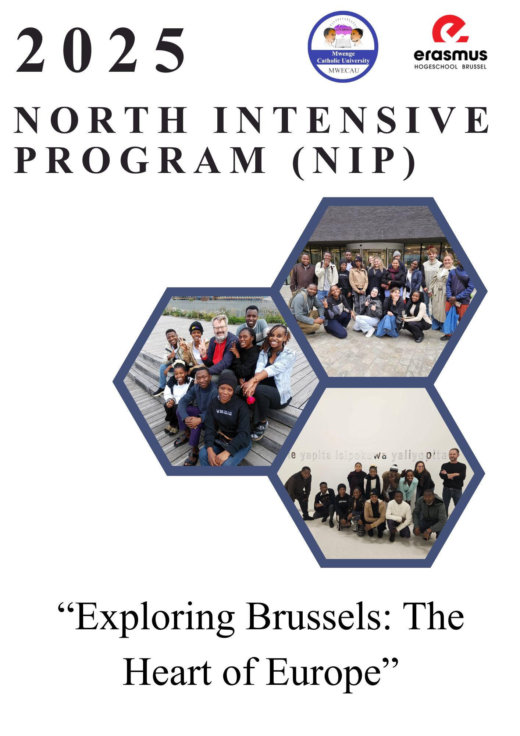

Contents

**North Intensive Program (NIP) Participants** 5

**Acknowledgment** 6

**Objectives of the Program** 7

**Abstract** 8

**Introduction** 9

**Day 1: History of Belgium and City Tour (Saturday, 11th October 2025)** 10

Places and Stories We Explored 10

**The story of the Brussels City Walls** 10

**Statues of King Albert I and Queen Elisabeth** 12

**The Royal Library (KBR) “Albertine / Albertino”** 13

**Stories about the present king and the next queen** 13

**Magritte and Bruegel the famous painters we heard about** 13

**The tunnel at Brussels Central Station** 15

**The cathedral with two towers St Michael and St Gudula** 15

**The Galeries Royales Saint-Hubert (the covered shopping arcade)** 15

**The Grand-Place (Grote Markt)** 15

**Sablon / Petit Sablon and the Church of Our Lady of the Sablon** 16

**Egmont Palace (Palais d’Egmont) and the nearby cemetery/statues** 16

**The small church “outside the site walls”** 16

**Day 2: Forest Day – Visit to Sonian Forest (Sunday, 12th October 2025)** 17

**Morning Activities** 17

**Main Activity – Visit to the Sonian Forest** 18

**What We Learned** 18

**Challenges Identified** 19

**Possible Solutions** 19

**Conclusion / Reflection** 20

**Day 3: World Expo 1958 and Botanical Garden (Monday, 13th October 2025)** 21

**Morning Activities – Planetarium Brussels** 21

**Challenges Noted:** 21

**Possible Solutions:** 21

**Meise Botanical Garden Afternoon Activities** 23

**What We Learned:** 23

**Challenges Found:** 23

**Possible Solutions:** 24

**Conclusion / Reflection** 24

**Day 4: Europe Day – Understanding European Integration and Democracy (Tuesday, 14th October 2025)** 25

**House of European History** 25

**Key Exhibits and Examples:** 25

**King Leopold II Statue** 26

**European Parliament** 26

**Overall Reflection** 27

**Visit to Hogeschool Brussels and City Tour** 27

**Democracy in Belgium and Tanzania Understanding** 28

**Democracy in Belgium** 28

**Democracy in Tanzania** 28

**Comparison and Reflection** 29

**Day 5: Molenbeek Visit and Social Work Exchange (Wednesday, 15th October 2025)** 30

**Morning Session: Exploring Molenbeek** 30

**Key Highlights of the Visit:** 30

**Afternoon Session: Meeting with Social Work Students** 31

**Reflection** 32

**Day 6: Journalism, Agro-Engineering, and Parliament Visit (Thursday, 16th October 2025)** 33

**The Morning Session: Journalism and Communication** 33

Afternoon Session: Agro-Engineering Visit at BIGH Farm, Anderlecht 33

**Evening Session: Visit to the Belgian Federal Parliament** 34

**Evening Activity: Karaoke and Cultural Exchange** 35

**Reflection** 35

**Day 7: Art and Climate Change (Friday, 17th October 2025)** 36

**Morning Session: Visit to HANGAR – “The Day May Break” Photo Exhibition** 36

**Afternoon Session: Visit to the Royal Museum of Fine Arts (Musées Royaux des Beaux-Arts)** 37

**Learning Outcomes** 37

**Reflection** 37

**Day 8: Africa Day – Exploring African Heritage and Cultural Connections (Saturday, 18th October 2025)** 38

**Morning Session: Visit to the Sablon Neighborhood** 38

**Afternoon Session: Visit to Tervuren and the AfricaMuseum** 38

**Discussions and Reflections** 39

**Learning Outcomes** 39

**Reflection** 39

**Day 9: Cathedral Visit and Departure (Sunday, 19th October 2025)** 40

**Morning Session: Visit to the Cathedral of St. Michael and St. Gudula** 40

**Afternoon Group Reflection and Farewell Session** 40

**We were talking about the following subjects**: 41

**Evening: Departure and Journey Home** 42

**Reflection** 42

**Final Conclusion and Overall Reflection** 43

**To sum up,** 44

# **North Intensive Program (NIP) Participants**

|  |  |  |
| --- | --- | --- |
| **SN** | **NAME** | **ROLE** |
| 1 | DR. GILEARD MINJA | Teacher |
| 2 | SIR.DENIS MBILINYI | Teacher |
| 3 | FAUSTINE MICHAEL EMMANUEL | BScCS Student |
| 4 | MARIAM GEKELA SHIMIYU | BScCS Student |
| 5 | LAUREEN JOHNSON KIDUNDA | BScCS Student |
| 6 | JESCA LEVIN NYONI | BScCS Student |
| 7 | SADOKI MOZES SADOKI | BAGEN Student |
| 8 | SELEMAN MAGERO WILSON | BAGEN Student |
| 9 | RENCYME SEME RODGERS | BAGEN Student |
| 10 | IRINE PAULO SAIDIMU | BAGEN Student |
| 11 | CLAUDIA BETROD KAZINGOMA | BAGEN Student |
| 12 | OSCAR BAHATI KARIONGI | BScCS Student |

**A Detailed Report regarding the North Intensive Program (NIP) Brussels and Belgium (11th–19th October 2025)**

# **Acknowledgment**

We the Tanzanian students of Mwenge Catholic University (MWECAU) want to give our warmest thanks to Erasmus University College Brussels for their effort in organizing and facilitating the North Intensive Program (NIP), which was held in Brussels, Belgium, from 11th to 19th October 2025.

To the fullest, we appreciate Prof. Stefan Moens as our primary mentor and storyteller who has helped us through the program with his empowering clarifications and unwavering support. His enormous knowledge of Belgian history, culture, and governance not only but also increased our educational journey and understanding of Europe.

Also, we would like to thank all the Belgian professors, coordinators, and students who not only welcomed us with open arms but also engaged with us during the lectures and field trips, and exchanged their cultural viewpoints with us. Their collaboration made this intercultural exchange educational, interactive, and unforgettable.

At Mwenge Catholic University, we express our sincere appreciation to Prof. Didas Kimaro, the director of the NIP program, for his strong leadership and guidance. We also want to acknowledge Dr. Gileard Minja, Sir Denis Mbilinyi, and Sr. Patricia Kijuu, who supervised us during the Field Practical Training and provided continuous support and mentorship before and during the program.

Our fellow Tanzanian participants are specially acknowledged for their cooperation, discipline, and oneness during the entire program. We together happily and with respect represented MWECAU and Tanzania.

We end with a thank you note to our families, friends, and university mentors for their constant support and prayers during the whole trip.

This remarkable experience demonstrates the strengths of the cooperation, the cultural exchange, and learning between Belgium and Tanzania.

We are sincerely thankful for being part of such an impactful international project.

Asante sana - Thank you so much!

# **Objectives of the Program**

The North Intensive Program (NIP) was created with the intention of facilitating the overcoming of borders in learning, understanding cultures, and making academic cooperation between students from Mwenge Catholic University (MWECAU) in Tanzania and Erasmus University College Brussels in Belgium.

While being part of this program, we set ourselves to accomplish the following objectives:

First of all, to promote intercultural comprehension through the direct interaction and teamwork of Tanzanian and Belgian students and professors, mixed with the learning of the European culture, values, and social systems.

Next, to experience the historical, political, and cultural heritage of Belgium, taking into account its main institutions such as the Belgian Federal Parliament, Royal Museum of Fine Arts, House of European History, and AfricaMuseum.

Furthermore, to go through the structure of European democracy and governance and make the comparison with the Tanzanian system in order to foster civic responsibility and global consciousness.

Moreover, to come to grips with sustainable development through the visits to the green projects like BIGH Urban Farm and other eco-innovation initiatives in Brussels.

Subsequently, to bolster academic and communication skills by way of group discussions, presentations, and collaborative reflections between the students from Tanzania and Belgium.

Then, to cultivate personal growth and leadership qualities through exposure to a multicultural learning environment that is characterized by open-mindedness, teamwork, and regard for diversity.

Finally, to utilize the knowledge gained through the travels to make educational, social, and eco-friendly practices in our communities and institutions in Tanzania better.

To sum up, the NIP program aimed at opening up our views to the world, promoting the understanding of different cultures, and gradually turning us into global citizens who would take on the responsibility of creating a better and more sustainable world.

# **Abstract**

In this report, the North Intensive Program (NIP) which took place in Brussels, Belgium, from 11th to 19th October 2025, is thoroughly summarized. The NIP was a joint effort of Mwenge Catholic University (MWECAU) and Erasmus University College Brussels. The main goal of this collaboration was to promote intercultural learning, academic partnership, and global comprehension of the two institutions' students through various activities like lectures, guided tours, discussions, and field visits.

The group of participants on the nine-day trip covered a broad range of topics such as European history and cultural heritage, democracy and governance, social work, journalism, arts, sustainability, and cultural exchanges. The most significant visits included Brussels' Federal Parliament, the Urban Farm BIGH, the Royal Museum of Fine Art, the House of European history, the African Museum in Tervuren, and the Molenbeek neighborhood.

The program was a great venue for exchanging ideas and seeing differences in social, political, and cultural practices between the two countries. It opened up the students' minds to the global problems of migration, climate change, and social inclusion, and at the same time provided them with an opportunity to enhance their critical thinking and collaboration skills.

In short, the North Intensive Program was nothing less than a revelation, it made us more aware of both Europe's and Africa's cultural heritage, and in addition, it had a brightening effect on our intercultural competence and on the application of the lessons learned for the good of education, sustainability, and cultural understanding in our regions.

# **Introduction**

The North Intensive Program (NIP) is a collaborative venture in which Mwenge Catholic University (MWECAU) in Tanzania and Erasmus University College Brussels in Belgium organize together an international academic and cultural exchange initiative. The 2025 program edition was held in Belgium, namely Brussels, from October 11 to 19, 2025, and was a manifold event with students and professors from both institutions engaged in the process of learning, sharing, and cooperating across the board culture-wise.

The program's main goal was to support and spread the goodness of global learning and understanding by showing the students the various social, cultural, and educational systems. The lecturers, guided tours, field visits, and interactive group activities were the main methods through which the participants examined some of the most important issues in today's society: heritage preservation, democracy, environmental sustainability, art, migration, journalism, and social inclusion.

The program made it possible for the participants to visit and study many important sites and institutions like the Belgian Federal Parliament, House of European History, Royal Museum of Fine Arts, BIGH Urban Farm, AfricaMuseum in Tervuren, and the Cathedral of St. Michael and St. Gudula. Each visit not only gave the participants a better understanding of how the past, governance and culture are contributing to the formation of Belgium and Europe but also opened the door to a new understanding of the continent and its processes.

Through joint discussions with Belgian students, we presented our opinions as Tanzanians and at the same time could not help but learn a bit the hard way, i.e. seeing the global challenges such as climate change, migration, and social inequality from several perspectives. The whole experience led to the enhancement of our academic knowledge, intercultural competence, and teamwork skills while making us realize the necessity of showing respect, being tolerant, and working together among the nations.

Through and through, the North Intensive Program 2025 was a bolstering experience that not only facilitated learning but also transformed us to be more tolerant, accountable, and universal involved citizens.

# **Day 1: History of Belgium and City Tour (Saturday, 11th October 2025)**

Brussels was the first destination of NIP in 2025. We came to the airport and took the train to the city. The first thing to do was to leave our luggage at Pieter Blügel Hostel, which would be our place to stay in Belgium for the next few days. After having lunch, we were ready for the first exploration of Brussels, with Professor Stefan Moens as our storyteller and city guide.

## Places and Stories We Explored

Pieter Bruegel Hostel

Most probably, we stayed in the Bruegel youth hostel close to the city center a hostel that is located in a very central area within a few minutes’ walk of Brussels Central and the Grand-Place. It’s a modern hostel that attracts mostly travelers and groups and is often utilized by student programs because of its closeness to central Brussels.

### **The story of the Brussels City Walls**

Brussels came into being as a small medieval town surrounded by a series of walls. The first fortifications, already in place during the 10th-13th centuries, were gradually added, and later medieval walls were built and rebuilt as the city expanded. During the 18th and 19th centuries, most of those walls were torn down (clearing the way for new streets and squares), and only fragments and names of places that once lay within the old limits survive. The guides usually recount some very thrilling tales about the walls, for the line of the former walls was decisive in the location of churches, gates, and important streets.

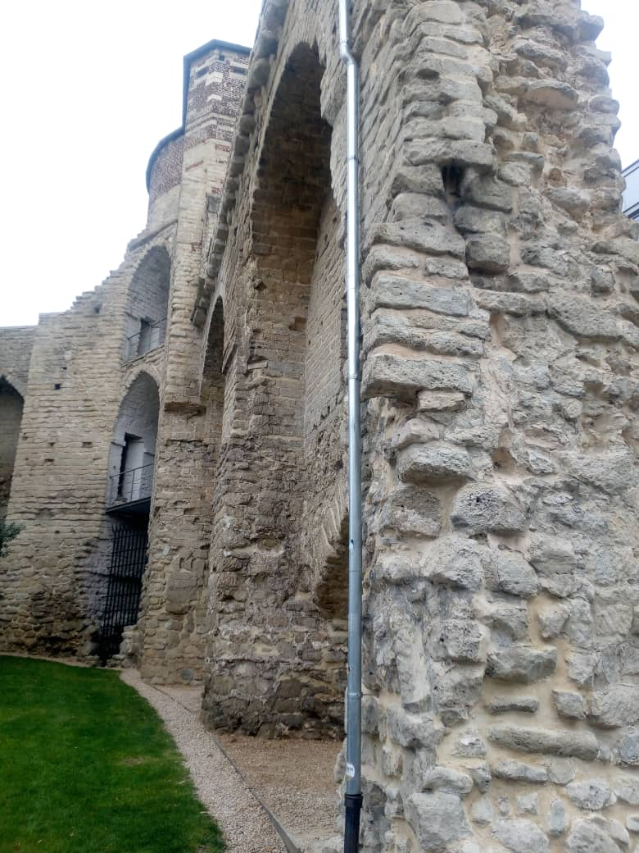

### **Statues of King Albert I and Queen Elisabeth**

Brussels has public monuments to King Albert I (an equestrian statue) and a statue of Queen Elisabeth (Elisabeth of Bavaria). Albert I (reigned 1909–1934) is widely considered a great king in Belgium due to his involvement in World War I and is thus honored by equestrian statue; a statue of Queen Elisabeth stands next to him as they are part of a 20th-century commemorative landscape in central Brussels. During the guides' explanations of Belgian national memory and the monarchy's involvement in the twentieth century, they point to these monuments.

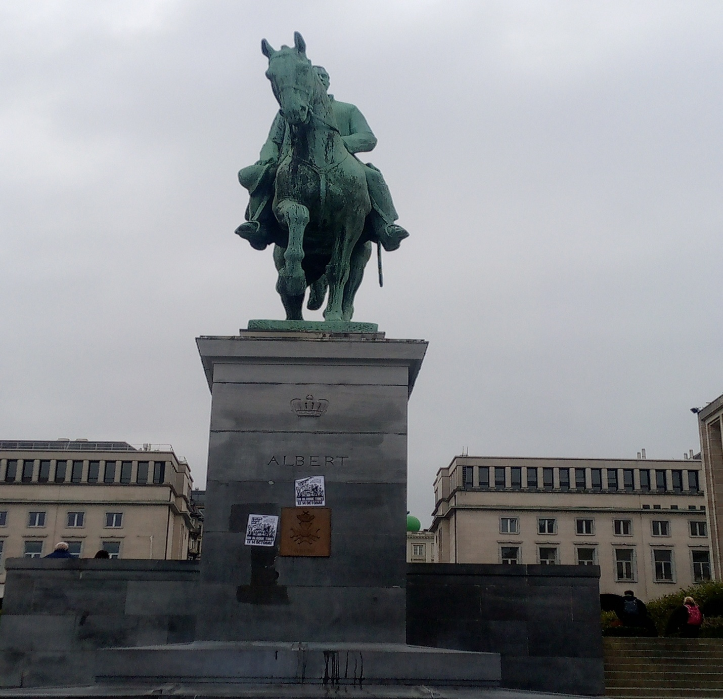

### **The Royal Library (KBR) “Albertine / Albertino”**

Officially the national library of Belgium is the Royal Library of Belgium (KBR). The locals sometimes refer to it as “Albertine” or “Albertina” because it has a long historical connection with King Albert I and the Mont des Arts/Kunstberg location. KBR maintains manuscripts from the time of the Dukes of Burgundy (15th century), possesses millions of items (prints, books, maps), and has recently upgraded and reopened its KBR Museum to display such treasures as the Library of the Dukes of Burgundy. If your guide referred to it as “Albertino,” that was probably a slang term used by locals or multilingual people; the official abbreviation is KBR (Bibliothèque royale / Koninklijke Bibliotheek).

### **Stories about the present king and the next queen**

As of 2013, the current reigning monarch is King Philippe (Filip) of the Belgians. The eldest child, Princess Elisabeth, Duchess of Brabant, is the heiress and is predicted to be the first queen regnant of Belgium when she takes the throne eventually (Belgium has absolute primogeniture so the firstborn child inherits no matter the gender). The guides usually talk about the royal family since royal palaces and monuments are located in the touristic area of the Royal Quarter.

### **Magritte and Bruegel the famous painters we heard about**

* René Magritte who lived from 1898 to 1967 was the leading figure of Belgian Surrealism and a mesmerizing painter at the same time; visitors to the Magritte Museum (part of the Royal Museums of Fine Arts) in Brussels, which houses several of his works along with contextual material for surrealism, have a chance to learn about his art and the surrealism movement as well.
* Pieter Bruegel the Elder, perhaps, the most significant Flemish Renaissance painter alongside his younger colleague of the same period, displays his artworks or their replicas in the Royal Museums of Fine Arts (also called Old Masters) in Brussels. When the guides narrate “stories” about Bruegel they would firstly tell how he influenced the northern European art and what moral lessons the peasant life and festivals depicted in his paintings give. Besides we visited the church near the hostel where Pieter Bruegel stayed, and we saw many things including the tomb of the great painter and his statue.

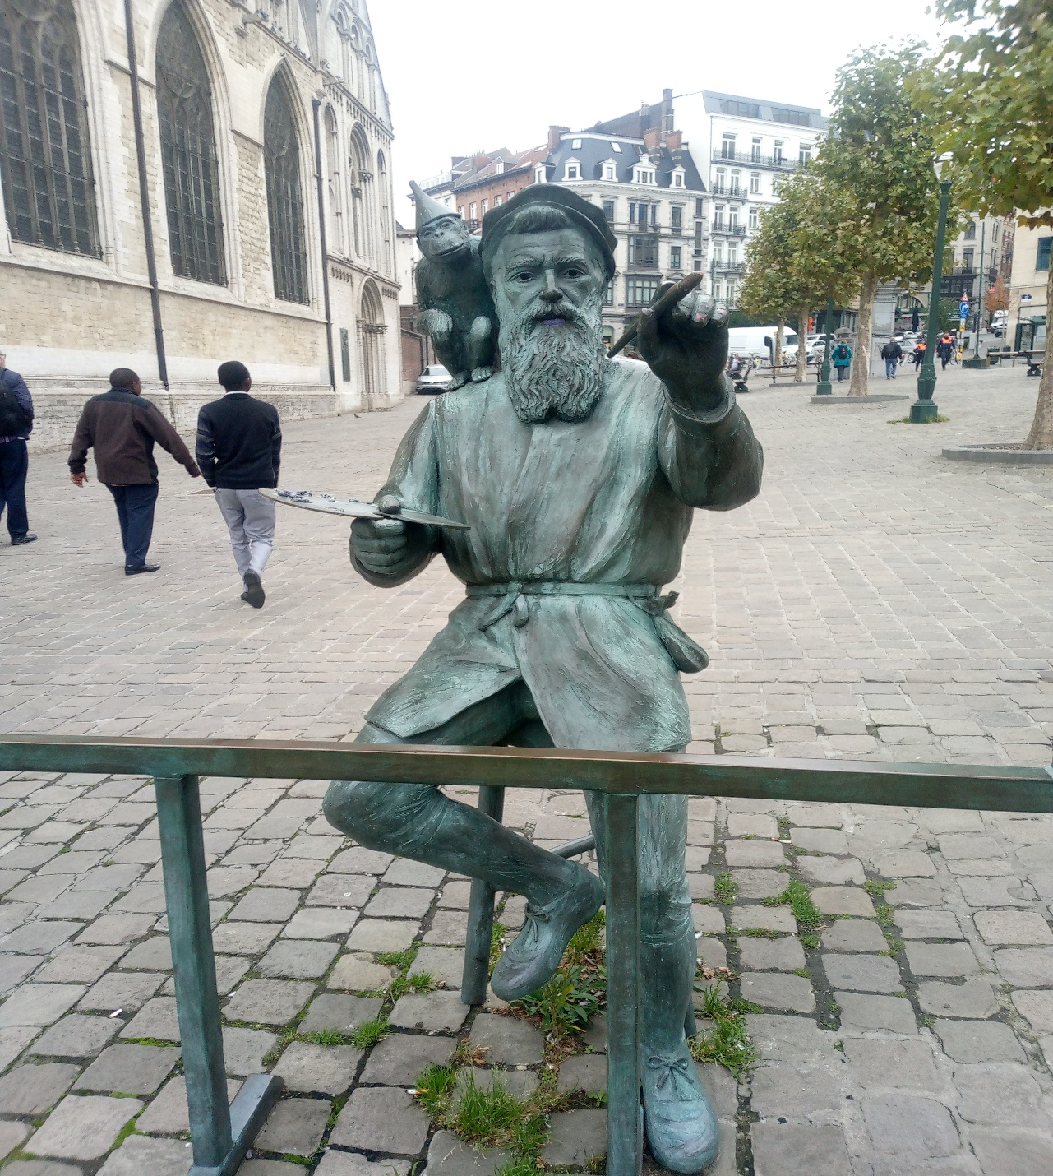

### **The tunnel at Brussels Central Station**

Brussels-Central is a huge station dating back to the 19th/20th century and is located right over the main rail "North-South connection" that runs underneath the city. The areas of the underground passage/tunnel have changed quite a lot in the last few decades with the renovations done (in the 2010s and afterwards) which have resulted in the central walkway being bright, safe, and well-ventilated. The long tunnel concourse was also redesigned, and the ventilation and safety works of the tunnels continued as part of long-term upgrades around 2013.

### **The cathedral with two towers St Michael and St Gudula**

The Cathedral of St. Michael and St. Gudula is the main gothic cathedral in Brussels. Its westerly front stands out due to two high towers (constructed approximately between 1470 and 1485) in the Brabantine/French Gothic style; the towers were left without the extremely tall spires that were originally envisioned, yet the twin-tower outline is a decisive image of the city. In addition to the lovely stained glass windows, the cathedral boasts gothic furnishings of great liturgical importance.

### **The Galeries Royales Saint-Hubert (the covered shopping arcade)**

Inaugurated in 1847, the Galeries Royales Saint-Hubert was a frontrunner in the development of Europe's covered shopping arcades, and it is 18th-century elegant glass-roofed archway filled with boutiques, chocolatiers, cafés, and libraries. The shopping arcade and the associated poor neighborhood were originally intended to be transformed into a more elegant and weather-protected street, but today the galleries serve both as a lively shopping area and a major tourist attraction.

### **The Grand-Place (Grote Markt)**

Brussels’ Grand-Place is the historic central square of the city, the UNESCO World Heritage site linked to the ornate guild houses, the tower of the Town Hall, and the King’s House (Maison du Roi). It is the heart of the ceremonies and commerce of the medieval and early-modern city; fire and bombardments led to the square’s rebuilding in the late 17th century, thus still serving as the most famous public square of the city (flower carpets, markets, concerts) at present.

### **Sablon / Petit Sablon and the Church of Our Lady of the Sablon**

* The Sablon (Zavel) neighbourhood is a historic hill of high-end, upper town known for antiques, chocolatiers and churches. The Sablon Church (Notre-Dame du Sablon), a 15th-century Brabantine-Gothic church, was supported by the royalty in its early years.
* Petit Sablon park (Square du Petit Sablon) is a small formal garden surrounded by an ornate fence whose pillars are topped by 48 small statues representing medieval/professional guilds, plus a semicircle of statues honouring 16th-century figures (the Counts of Egmont and Horn are central to the garden) that’s the “statues you saw and your guide explained.” It’s a deliberate 19th-century memorial garden (laid out in 1890) celebrating local civic history.

### **Egmont Palace (Palais d’Egmont) and the nearby cemetery/statues**

The Egmont Palace is a historic landmark with a mix of the original 16th-century and later styles which was home to the influential Egmont family (the most famous member, Lamoral, Count of Egmont was executed in 1568). Currently, the palace is the site of state receptions, and events (and the Egmont Institute takes its name from it) among other activities. The Petit Sablon park and the neighboring church hold memorials and statues linked to Egmont's saga; the majority of the sculptural elements in the area are the result of 19th-century restorations and commemorations of the figures from the 16th-century.

### **The small church “outside the site walls”**

There is a strong possibility that this speaks of the early chapels or cemeteries that occupied sites just beyond the medieval walls of Brussels (for instance, chapels devoted to the Virgin in the Sablon district were initially outside the city limits). A majority of the churches started off as tiny chapels outside the walls (often catering to militia or guilds) and were later expanded as the city grew; the narrative your guide provided regarding a church outside the walls coincides with that common historical pattern in Brussels.

# **Day 2: Forest Day – Visit to Sonian Forest (Sunday, 12th October 2025)**

Visit to the Sonian Forest (Forêt de Soignes) – Flanders

Guiders: Prof. Steven & Prof. Stefan

Starting Point: Pieter Bruegel Hostel, Brussels

Destination: Groenendaal – Sonian Forest

Time: 12:52 p.m. – 4:08 p.m.

## **Morning Activities**

The day started with breakfast at the Pieter Bruegel Youth Hostel, after which we had a short morning walk around Les Marolles, a Brussels neighbourhood that is vibrant and multicultural. This visit allowed us to see how Belgians go about their daily lives, how they interact with each other, and how different cultures happily coexist in one city.

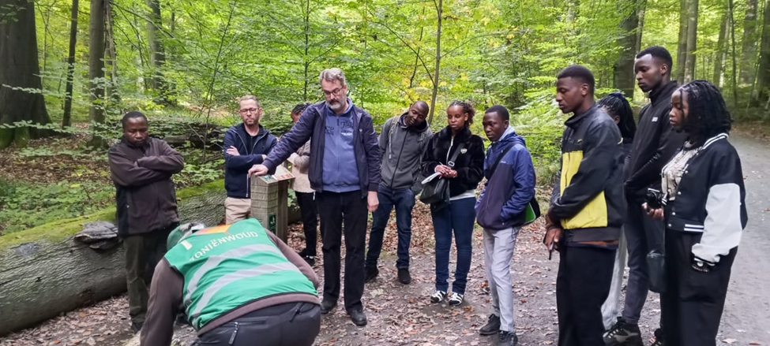

## **Main Activity – Visit to the Sonian Forest**

After having lunch, we hopped on the train from Brussels Central Station to Groenendaal, where Prof. Steven, our guiders for the day, received us. We went together to the Sonian Forest, which is the most important natural heritage site in Belgium and is also one of the parts of the ancient beech forest that once occupied a big part of the Western Europe.

The guider at the Sonian forest explained that the Sonian Forest (Forêt de Soignes) is a forest of over 4000 hectares to be exact, covering the three regions of Brussels, Flanders, and Wallonia. It consists of many centuries-old European beech and oak trees, among them some over 200 years old, and hosts lots of animal species like deer, foxes, badgers, and various bird species. The forest is classified as a UNESCO World Heritage Site due to its ecological and historical importance.

### **What We Learned**

We were informed about the following topics during the guided tour and at the Forest Museum:

1. Biodiversity:

The forest is diverse in terms of both plant and animal species. It acts as a significant green corridor that facilitates wildlife movement between urban and rural areas.

1. Forest Ecology:

The professors elucidated that beech trees are the ones that grow tall and close together forming a canopy that blocks out sunlight completely, thus determining the growth of plant types on the forest floor.

1. Climate Role:

The forest is crucial in terms of being a carbon sink, air pollution mitigation, and ensuring cooler temperatures in the area around Brussels.

1. Conservation Efforts:

Sustainable forestry practices, reforestation projects, and strict protection policies contribute to the maintenance of the natural balance that we learned about.

1. Human Interaction:

We saw the forest being used by people for recreation, education, and research purposes while they were at the same time respecting the environment.

1. Education and Research

The Sonian forest is utilized for education and research purposes to find out how long it will take for the complete tree to decay.

## **Challenges Identified**

Prof. Steven and Prof. Stefan also talked about the different challenges that the Sonian Forest had to deal with:

1. Urbanization Pressure:

The growth of the city of Brussels is slowly encroaching upon the forest area by way of roads, housing, and pollution.

1. Tree Diseases:

Certain areas of the forest are afflicted by illegal logging as well as diseases that mainly affect beech trees.

1. Climate Change:

Natural temperature increase and changing rainfall patterns are impacting tree growth and water supply.

1. Human Disturbance:

Nature and the forest area are being affected negatively by visitors' noise, littering, and the general overuse of the area.

1. Biodiversity Loss:

Some plant and animal species are being lost as a result of habitat fragmentation and genetic isolation.

## **Possible Solutions**

In solving the aforementioned problems, the group managed to outline and even discuss several factors that could help to minimize the impacts of the above-mentioned issues:

1. Strict Protection Laws:

To continue enforcing such laws, one would need to control urban expansion near the borders of the forest areas.

1. Environmental Education:

To create public awareness of forests and their value, guided tours, school programs, and community projects could be used.

1. Sustainable Tourism:

To promote eco-friendly tourism that limits the pollution and regulates the number of tourists.

1. Tree Replanting Programs:

The replacement of the old and diseased trees with the young and healthy ones of the same species will help keep the forest in balance.

1. Research and Monitoring:

To provide support for scientific studies that will monitor the climate impacts, population of the wild animals, and the health of the forests.

## **Conclusion / Reflection**

Our excursion to the Sonian Forest was indeed housing both a learning experience and a source of inspiration. Led by the professors, Steven and Stefan, as well as the ranger in the forest, we saw the possibility for nature and urbanization to coexist if only there would be proper management of the forests. It became our knowledge that the safeguarding of forests like the Sonian is not just a national but also a global responsibility for the climate stability, biodiversity conservation, and the good health of future generation.

This event made the environmental protection approach stronger in us, and also made the small, however, very important actions like acting in goodwill to nature and waste reduction, seem like a case of the planet being made sustainable.

# **Day 3: World Expo 1958 and Botanical Garden (Monday, 13th October 2025)**

Guiders: Prof. Stefan, and Prof. Steve Goossens (Landscape & Garden Architecture)

Destinations: Planetarium Brussels & Meise Botanical Garden

## **Morning Activities – Planetarium Brussels**

After breakfast at the Pieter Bruegel Hostel, our next move was to the metro station for a ride to Heizel, where the 1958 World Expo took place and that the Atomium, a landmark of Belgium and symbol of the scientific and cultural unity after WWII, part of the site.

The first thing we did was to visit the Boiler of Brussels, where we were introduced to a grand dome theatre with a 360° projection of the night sky and space phenomena. It was guided by the Planetarium staff and Prof. Stefan Moens, during which we learned about:

* The solar system containing planets, moons and their motions.
* Earth's formation.
* Milky Way Galaxy and Earth's location in it.
* Astronomy's role in timekeeping and climate pattern understanding.
* The important role of satellites and telescopes in monitoring Earth's weather and environmental changes.

## **Challenges Noted:**

1. One of the challenges is the limited funding for public science education, which leads to a decrease in astronomy learning access.
2. Overdependence on technology without environmental awareness can result in humans becoming disconnected from nature.

## **Possible Solutions:**

* Strengthen environmental education by introducing astronomy programs in schools.
* Promote public interest in science through having open exhibitions and school partnerships.

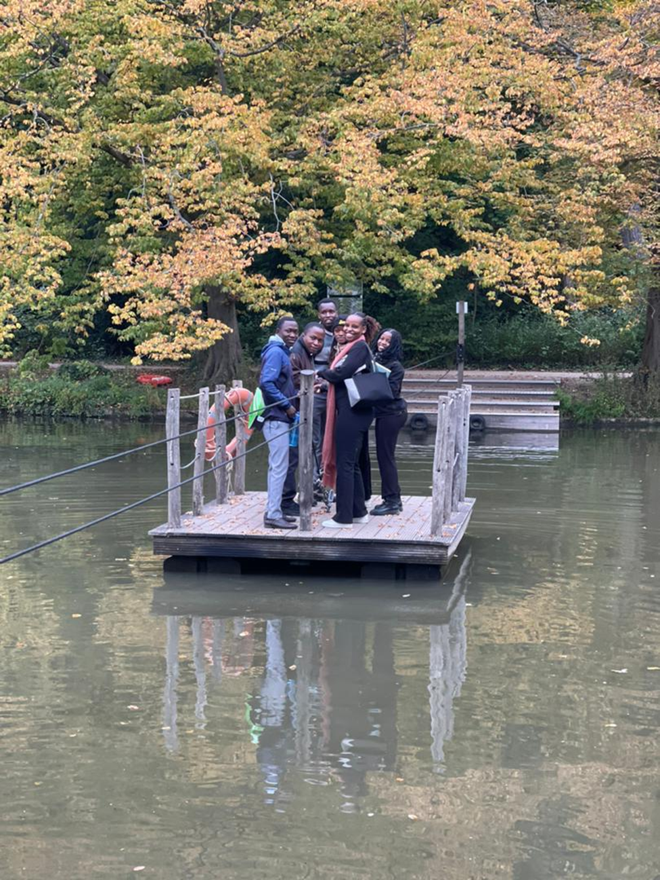

## **Meise Botanical Garden Afternoon Activities**

After lunch in the vicinity of the Meise, the largest botanical garden in Europe, which is about 92 hectares in area, we met the renowned landscape and garden architect Prof. Steve Goossens who took us on a tour of this beautiful garden. He told us that the Meise Botanical Garden houses more than 18,000 plant species from different parts of the world such as medicinal plants, tropical trees, orchids, succulents, and endangered plants. The Plant Palace, a large greenhouse with various climatic zones - tropical, desert, and Mediterranean - was our next stop.

## **What We Learned:**

1. Plant Diversity: The garden is protecting global biodiversity and facilitating scientists' research on endangered and useful plants.
2. Medicinal Plants: A number of plants have healing effects and we got to know how the natural compounds are contributing to modern medicine.
3. Climate Zones: The greenhouse is showing how different plants are able to withstand different hot, cold, wet, or dry conditions.
4. Sustainable Landscape Design: Prof. Goossens shared how the garden takes advantage of rainwater collection, composting, and energy-efficient systems to lessen the volume of waste produced.
5. Scientific Research: The garden is in collaboration with universities across the world in the research of how plants adjust to climate change.

## **Challenges Found:**

1. Climate Change: Unpredictable weather and increasing temperatures are endangering the survival of both native and exotic species.
2. Invasive Species: Occasionally, non-native plants become too dominant and thus affect biodiversity negatively.
3. Funding Constraints: The costs of keeping large greenhouses and carrying out research projects run very high.
4. Pollution: Sensitive species can get affected by air and soil pollution and their growth rates may also get reduced.

## **Possible Solutions:**

1. Expand Conservation Programs: Urge governments and NGOs to support the efforts for plant preservation.
2. Promote Eco-Tourism: Income to be generated through responsible tourism that supports conservation.
3. Public Education: Awareness of the importance of plants for food, medicines, and climate change to be raised.
4. Green Technology Use: Maintenance of sustainability to be done through the application of solar energy, smart irrigation, and waste recycling.
5. Collaborate Internationally: Plant seeds and knowledge to be exchanged with other botanical institutions.

## **Conclusion / Reflection**

The Planetarium and Meise Botanical Garden day had a huge impact on our comprehension of the nexus between science and nature. We have seen that astronomy helps mankind in understanding his position in the cosmos, while botany reveals the fact that life on Earth is dependent on the existence of healthy ecosystems.

The two visits were a reminder that it is not enough to just acquire knowledge, one should also care for the environment. Climate change, pollution, and resource depletion challenges can only be addressed through a combination of education, innovation, and international collaboration.

# **Day 4: Europe Day – Understanding European Integration and Democracy (Tuesday, 14th October 2025)**

Our stay in Brussels offered us the privilege of visiting some of the most significant locations that depict the history, culture, and political aspects of Europe. These experiences helped me to grasp better Europe’s historical evolution, the colonial period, and the present-day organization of the European Union.

## **House of European History**

The House of European History is a contemporary museum that narrates Europe’s historical rivalry and union in coexistence from the beginning of the 20th century to the present day. It shows how Europe was able to surmount wars and ruin eventually through the European Union to gain peace, unity, and cooperation.

### **Key Exhibits and Examples:**

* World Wars: Original soldiers’ uniforms, propaganda posters, weapons, and ration cards were presented in a way that showed the impact of the world wars on the lives of Europeans.
* European Coal and Steel Community (ECSC): One of the displays consisted of photographs of Schuman and Monnet, documents from the ECSC Treaty, and an explanation of how coal and steel cooperation was a catalyst for peace and no more wars.
* Formation of the European Union: Copies of the Treaty of Rome (1957), old European passports, and interactive maps indicating EU enlargements gave insights into the formation of the EU.
* Free Movement and Schengen: A border gate that had been demolished along with the road signs denoting the end of the checks between the countries within Europe represented the free flow of people within the EU.
* Common Currency: The transition to the Euro currency which came in 2002 is illustrated with the old European currencies, such as francs, lira, and marks being exhibited alongside euro coins and notes.
* European Standards: A case in point illustrating how EU regulations implement uniformity across products, is the banana size regulation and the chocolate content rules, which were among the examples.
* European Citizenship: EU ID cards, Erasmus student exchange videos, and exhibits showing the freedom to work and move within the member states.
* Criticism and Debate: Interactive monitors where visitors can express their views about the bureaucracy and EU decision-making.

With the help of this visit, I was able to figure out that Europe has learned from its past conflicts to promote peace, unity, and democracy.

## **King Leopold II Statue**

The next place I visited was the statue of King Leopold II, who was one of the most controversial historical figures in Belgium. Our guide told us that from 1865 to 1909, King Leopold II ruled Belgium and kept the Congo Free State as his personal colony. The statue is a reminder of both the historical pride of Belgium and the dark colonial past linked with Africa's exploitation.

This visit imparted the knowledge that Belgium is still very much in a state of reflection regarding its colonial past, and public discussions are taking place about the need for such monuments to be replaced with more educational displays.

## **European Parliament**

During the sightseeing, I got close to the European Parliament, which is considered an important pillar of the European Union. The guide shared the following points:

• The institution is a voice for people from all the EU countries.

• Each term of 5 years sees the election of the European Parliament Members (MEPs) through popular vote.

• Legal regulations that pertain to all European citizens are co-authored by it, the European Commission and the Council of the EU.

• Brussels is the main seat of the Parliament but it also meets in Strasbourg, and the public has the chance to see and hear the discussions and votes.

Moreover, even though we did not tour the interior of the building, we approximately got the same picture of the European democracy process and the laws passed there that have ripple effects through every member country.

## **Overall Reflection**

This whole tour enlightened me about the transformation of Europe from colonialism and conflict through to democracy and unity. At the European History Museum, it was shown that cooperation created peace; the statue of King Leopold II made me aware of the necessity to confront historical truths; and the European Parliament was a living demonstration of how Europe is still fostering the sharing of decisions and common values among its nations.

In a way, all these experiences turned our trip to Brussels into an educational and inspirational one.

## **Visit to Hogeschool Brussels and City Tour**

In the afternoon, we went to Hogeschool Brussels where the Tanzanian students were together with the Belgian students for a learning and cultural exchange activity. Each group made up of four students three Belgian students and one Tanzanian student. Our Belgian peers took us on a 90-minute walking tour around the city where we went together.

During the tour, our group went to some of the city’s most important landmarks, including:

* Manneken Pis Statue which is the main symbol of Brussels showing humor and independence.
* The House of Beer a spot that highlights Belgium’s brewing culture and history.
* Grand Place (Grote Markt) a UNESCO World Heritage site famous for its gorgeous buildings and historical significance

We were not very far from the city center because there was a national strike going on that day. People were in large numbers protesting against the government decision of raising the retirement age to 67 years before people could draw their pensions. This strike was quite an event through which we could see and learn how people in Belgium use their right to protest peacefully, which is one of the democratic rights.

After the 90-minute walk, we went back to the university and had a discussion session on democracy. Together with the Belgian students, we thought about what democracy means in both Belgium and Tanzania, and we got to know how the Belgian government works its federal system, parliamentary democracy, and the role of citizen participation in decision making being the important ones.

This exercise was extremely instructional because it not only gave us a chance to see the beauty and history of Brussels but also to get an awareness of democracy, civic rights, and the multicultural cooperation through practical means.

## **Democracy in Belgium and Tanzania Understanding**

As soon as we wrapped up the city tour, our classroom discussion revolved around dissent in Belgium and Tanzania. The two countries were not only different in terms of geography, history, and culture, but they also equally treasured democracy and that is the reason why and people had the right to choose their rulers and also participate in the decision-making process of the country.

### **Democracy in Belgium**

Belgium operates as a federal parliamentary democracy and constitutional monarchy. This scenario means that:

* King serves as the head of state whereas the Prime Minister is the head of the government.
* The central government, regions, and communities share power which gives local governments the opportunity to take up decisions that suit their populations the best.
* Voters at federal, regional, and European levels directly elect the members of parliament through elections.
* Abolition and protection are given to the rights of free speech, religion, and assembly, thus allowing everybody the right to express their views and to organize protests peacefully, such as the nationwide strike that we witnessed.
* The government operates on the basis of power-sharing, equality, and participation among the three linguistic and cultural groups represented in the country (Dutch, French, and German speakers).

### **Democracy in Tanzania**

Tanzania operates as a unitary presidential democracy in which:

* The President acts as both head of state and head of government.
* People choose their representatives through general elections every five years.
* Political activity is open to multiple parties, but the ruling Chama Cha Mapinduzi (CCM) party has been in power since the country was established.
* The Parliament (Bunge) has the power to make laws and safeguard the people's concerns.
* Tanzanian democracy spreads the values of peace, unity, and national stability, and each citizen has the right to take part in development and local decision-making.

## **Comparison and Reflection**

The discussions revealed that Belgium and Tanzania, although their structures are different, both aim to give people participation and to respect individual rights. The main point in Belgium’s democracy is the sharing of power among the regions and communities, while in Tanzania the main point is national unity and centralized decision-making.

This experience made us realize that democracy can wear different faces depending on a country's history and culture but its essential values of freedom, participation, equality, and justice still prevail.

# **Day 5: Molenbeek Visit and Social Work Exchange (Wednesday, 15th October 2025)**

Our fifth day was given over to the examination of Molenbeek, which is the most multicultural commune in Brussels, and the social issues surrounding it, like inclusion, migration, and community development. It was clear by the end of the day that art, culture, and social work were the main factors in creating peace in societies with different backgrounds.

## **Morning Session: Exploring Molenbeek**

We went to Molenbeek after breakfast, which is one of the most diverse areas of Brussels and the centre of various community initiatives. Our guide first brought us to some important landmarks, and then introduced to us various stories and institutions along the way.

### **Key Highlights of the Visit:**

* Story of Paul Van Hoeydonck:

We were told the story of Paul Van Hoeydonck, a Belgian artist who, among other things, rendered the only sculpture in the moon known as “Fallen Astronaut”. This story proved how Belgian artistry had got a spot on the global map and represented the triumph of mankind and the coming together of art and science through this.

* The Canal of Brussels:

We took a trip to the Brussels Canal, where we were educated on its past and economical factors influencing its present. The canal was intended to link Brussels with other cities for the purpose of transport and trade then, and it is still a main player in the urban and recreational areas today.

* The Little Castle (Le Petit Château):

We went round the Little Castle, which is the home for asylum seekers and refugees. Our guide told us about the building, its occupants, and how it is providing temporary shelter and assistance to migrants and refugees coming to Belgium. It is a symbol of kindness and social obligation in helping those who are vulnerable.

* Molenbeek Buildings and Institutions:

We were shown various public buildings and told about the community services, like youth programs, educational centers, and integration projects, which help the residents to adapt and contribute to society.

* The Central Square of Molenbeek:

We walked across the main square which is a gathering place for various people. It indicates the social diversity and cultural richness of Molenbeek.

* Academy of Arts and Museum:

The Academy of Arts andlocal museum were our destination where we could view paintings, sculptures, and historical exhibits that focus on the artistic life and the heritage of the Molenbeek's community. Art has been shown on the exhibits as an identity, emotion, and social connecting medium.

* House of Culture:

At House of Culture, the audience was informed about the activities giving rise to intercultural dialogue, creativity, and education via theater, music, and exhibitions. The center plays an important role in cultural gap filling and understanding building among the locals.

* Migration Museum:

The most significant tour was the Migration Museum, which made us familiar with different migration, identity, and belonging stories. We viewed personal objects, pictures, and narratives highlighting the paths and hardships of migrants who moved to Belgium for a better life. This tour made us realize how much society today needs respect, empathy, and inclusion.

## **Afternoon Session: Meeting with Social Work Students**

The tour was followed by our visit to Campus Kanal where we met students of Social Work from Belgium, all thanks to Professor Lucie De Meyst.

The session was very participatory and it was mainly through the sharing of experiences that the two student groups from Tanzania and Belgium were interacting.

**The topics were:**

* The social workers' functions in giving support to the local people.
* How the two countries deal with migration, poverty, and youth challenges.
* The role of education and empowerment in creating peaceful and just societies.

The discussion came to a close together with a drink, which was an opportunity for us to create bonds and share our cultures one more time.

## **Reflection**

The trip to Molenbeek was a very impactful learning experience. It provided us with a thorough understanding of urban diversity, migration, and social inclusion in the European context.

Not only did we get the narrative of Paul Van Hoeydonck but also through the visits made to the community centers, museums, and art academies, and our discussion with the social work students, we got to know how Belgium utilizes art, culture, and social work to bridge the gap among people with different backgrounds and even to unite them.

This experience made us think of implementing similar ideas in Tanzania, especially in the areas of community cooperation, empathy, and social well-being promotion.

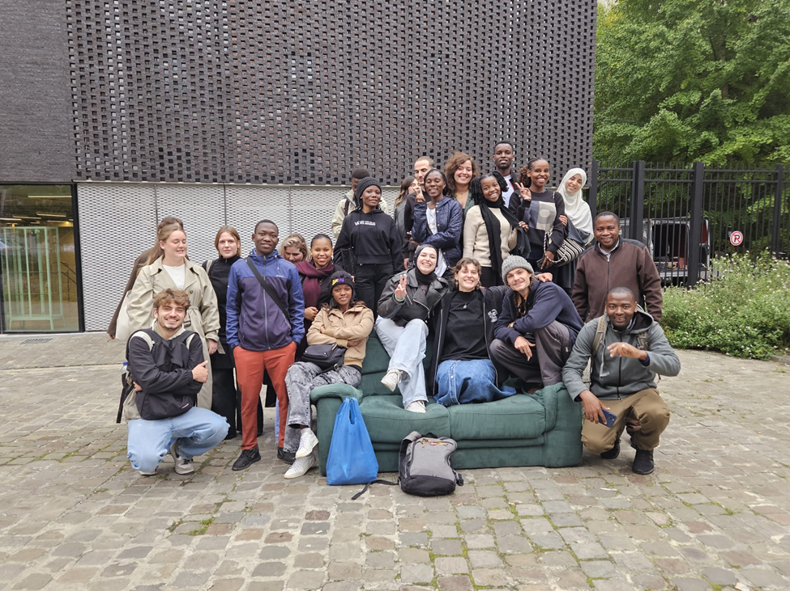

# **Day 6: Journalism, Agro-Engineering, and Parliament Visit (Thursday, 16th October 2025)**

The sixth day of the program was very memorable; a mix of already-mentioned practices and live educational sessions related to communication, sustainable agriculture, and political awareness. It was a day that related the importance of media, environment, and governance in creating a society with a better quality of life.

## **The Morning Session: Journalism and Communication**

After having breakfast at the hostel, we proceeded to the university campus for a session on journalism. The session was conducted by Professor A. Verschuere, who was responsible for introducing us to the practices, ethics, and the pivotal role of media in democracy of the Belgian journalism.

**During the lecture, and group discussion, we discovered:**

* The journalist's position in public informing and government tipping.
* The press freedom that is considered as an essential part of democracy in Belgium and the EU.
* The digital media impact and how journalists are to weigh precision of information against the speed of online news.
* The place of truth, neutrality, and ethics in reporting, especially in a vast and democratic society.

We also had a comparison between the journalism practices in Belgium and Tanzania, pointing out that both countries uphold freedom of expression as a central value, but also face challenges like misinformation and resource limitations.

The interaction with the students of Belgian journalism opened our eyes to the fact that the media, through its different roles, connects people, influences opinions, and aids in making the governance transparent.

## Afternoon Session: Agro-Engineering Visit at BIGH Farm, Anderlecht

After having our lunch at the Campus Bloemenhof, we then moved to BIGH Farm (Building Integrated Greenhouses) at Anderlecht, a very modern project which is all about urban agriculture and aquaponics.

**As we walked through the farm, we had the opportunity to learn about:**

* Aquaponics systems, which are a combination of fish farming and vegetable growing in a closed-water cycle.
* How fish waste becomes the source of nutrients for plants, and plants, in turn, purify water for the fish creating an eco-friendly system.
* The farm’s aim of producing fresh food locally, hence, minimizing transport costs and also, contributing to urban sustainability.
* The partnership of technology and agriculture as a way of combating climate change and food insecurity in the cities.

The visit provided us with the knowledge on the necessity of innovation and sustainability in the agricultural sector — a lesson that can as well be replicated in Tanzania to better the farming practices as well as lessen the environmental impact.

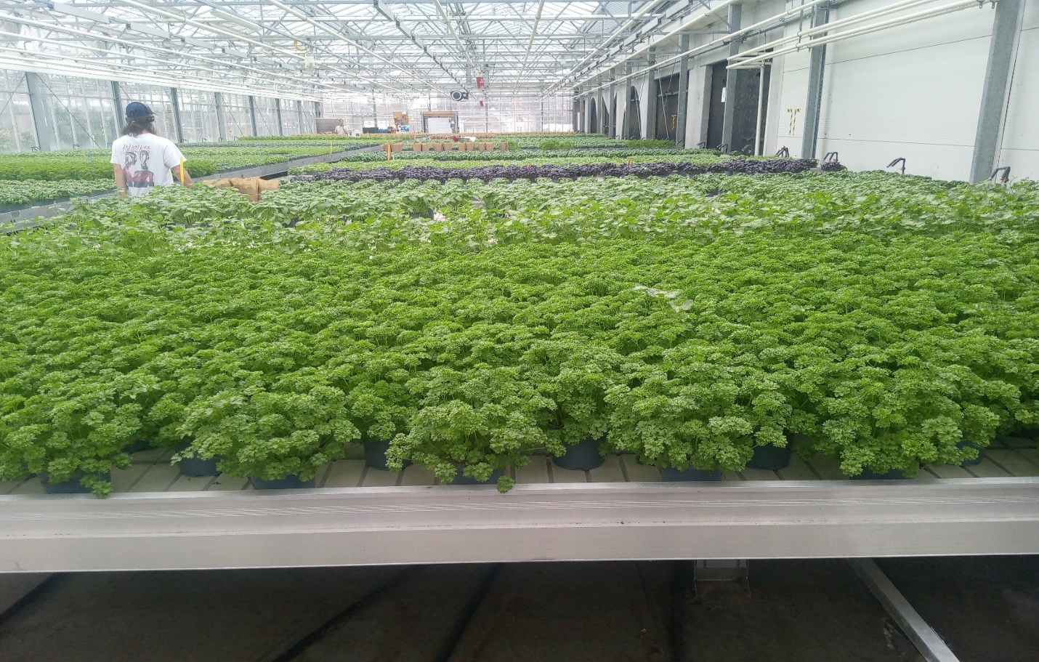

## **Evening Session: Visit to the Belgian Federal Parliament**

In the late afternoon, we had a tour of the Belgian Federal Parliament, where we got acquainted with the structure and functions of the Belgian government.

Our guide told us that Belgium is a federal parliamentary democracy and constitutional monarchy, **which means that**:

* The King is the symbolic ruler of the country while the Prime Minister is the executive authority.
* The legislature is bicameral, which means it consists of the Chamber of Representatives and the Senate.
* The people vote for Parliament members who will fight for their rights and create the laws.
* The Parliament is in the constant interaction with the European Union institutions which are situated in Brussels.

We even touched on the comparison between Belgium's parliament and Tanzania's Bunge (National Assembly). Both nations consider public participation and democracy important, however, Belgium has a more decentralized system that lets regions (such as Flanders, Wallonia, and Brussels) have their own parliaments and governments.

## **Evening Activity: Karaoke and Cultural Exchange**

It was a lovely evening, comprised of a Karaoke event along with the entry of students from the Journalism school who organized the event at RITCS Café.

The evening was a relaxing and enjoyable one, with amazing cross-cultural interaction taking place through singing and dancing and even sharing songs between Belgian and Tanzanian students. This was a great way to solidify our bonds and reinforce the very idea that creativity and cultural exchange are indeed the cornerstones of international learning programs.

## **Reflection**

This day comprised one of the most varied and stimulating days during our stay.

Each activity, starting from media ethics in journalism through sustainable farming at BIGH Farm, to understanding democratic processes in Belgian Parliament, showed us how communication, innovation, and governance together can create a better and fairer world.The experience activated our critical thinking, encouraged us to collaborate, and made us apply these lessons back in our own communities in Tanzania especially in the areas of responsible journalism, environmental care, and civic participation.

# **Day 7: Art and Climate Change (Friday, 17th October 2025)**

The seventh day of our program was dedicated to understanding how art can be a tool for environmental problems to be communicated and social transformations to be inspired. Visiting art exhibitions and museums, we witnessed the power of creativity to raise awareness about climate change, wildlife protection, and the human responsibility towards nature.

## **Morning Session: Visit to HANGAR – “The Day May Break” Photo Exhibition**

After the hostel breakfast, we went to the HANGAR Art Center in Brussels to see the “The Day May Break” photo exhibition made by Nick Brandt, a British photographer who is very popular for his environmental and wildlife photography. The exhibition showcased stunning pictures taken in dark and difficult situations but displaying a great deal of hope among the saved and suffering lives of humans and animals, where the life cycle is affected by climate change, deforestation and pollution. A lot of the images were from Africa, including Kenya and Zimbabwe, which made the exhibition especially significant for us as Tanzanian students.

**From the exhibition we gained the following insights:**

* Art can powerfully influence the field of environmental education, and it can also be a powerful and effective means of protest.
* Global warming is no longer a concern for Europe only; it is a common issue that has implications for both people and animals everywhere.
* The photos provoked thoughts about how mankind could live peacefully with nature instead of overpowering it.

Additionally, we had a conversation about how Nick Brandt and other similar artists employ photography to not just document but also to influence policy and public sentiment, thereby leading society towards being more planet-friendly.

## **Afternoon Session: Visit to the Royal Museum of Fine Arts (Musées Royaux des Beaux-Arts)**

The Royal Museum of Fine Arts, another one of Belgium's top art centers, became our next destination after having lunch at Campus Bloemenhof. The museum houses a huge collection of artworks that span from the 15th century to the present day, featuring works by both Belgian and European artists, among them:

* Pieter Bruegel the Elder (1525-1569) – He is known for his paintings that depict peasant life and the countryside.
* Peter Paul Rubens (1577-1640) – He is recognized for his bold religious and historical paintings that are full of life and color.
* René Magritte (1898-1967) – A surrealist artist whose themes revolve around imagination and human perception.

The visit to the museum opened our eyes to the fact that the art, besides being a mere aesthetic, could practically tell the stories of history, religion, politics, and environment, and above all, it could simulate the connection among people of different ages.

Modern art sections were also part of the museum showcasing how today's artists are dealing with the current issues like global warming, migration, and equal rights through their visual expressions.

## **Learning Outcomes**

We drew a number of crucial conclusions from both the HANGAR exhibition and the Royal Museum of Fine Arts:

* Art is not simply a matter of beauty, but also of awareness and change.
* The artists are the ones who are educating the public and swaying the opinion on worldwide issues through their art.
* The art world and sustainability issues are closely tied up as the art tactility can be a good way to encourage the people to be more environmental friendly.
* The investments made by Belgium in the art sector is a clear indication that the country is committed to the maintenance of its cultural heritage and education through art.

## **Reflection**

Day 7 was an extremely emotional and stimulating day. The exhibitions made us understand the synergy between art and climate action which is a very strong reminder of the fact that creativity can always be channeled to bring about change that is good.

The Tanzanian students pondered over how artists in Africa could very well be the ones to talk about issues like logging, wildlife interference, and conservation in our neighborhoods.

This day bonded us even more in our conviction that education, art, and sustainability are the three pillars of the future that is good for everyone.

# **Day 8: Africa Day – Exploring African Heritage and Cultural Connections (Saturday, 18th October 2025)**

The eighth day of our program was named Africa Day, and it turned out to be one of the most memorable and tearful moments of our trip to Belgium. This day had the intent of investigating the historical and cultural bonds between Africa and Europe, focusing on the ways in which Africa is depicted in the history and art of Belgium. Visits and debates enabled us to see not only the splendor of African culture but also the tragic story of colonization.

## **Morning Session: Visit to the Sablon Neighborhood**

We started the day after having breakfast in the hostel by visiting Sablon neighborhood, a historic part of Brussels famous for its art galleries, antique shops, and magnificent churches, like Notre Dame du Sablon, built in the 15th century.

Our guide told us that Sablon used to be the place of luxury where rich merchants and artists lived. Nowadays, it is the cultural space where Belgian and international artists exhibit their work.

Moreover, we got to know that Sablon area is linked to the city's colonial history since the wealth that built Brussels came from Belgium's ex-colonies, mainly the Congo Free State (now the Democratic Republic of Congo).

## **Afternoon Session: Visit to Tervuren and the AfricaMuseum**

We took a tram to Tervuren, a suburb of Brussels, after lunch to go to AfricaMuseum (Royal Museum for Central Africa). This museum was the way King Leopold II opened in 1897, to present the Congo Free state's most extracted and most valued items and materials.

In the course of our guided tour, we sporadically heard about the renovation and the reopening of the museum in 2018 in order to give a more honest and fair perspective of Africa's history.

**The exhibits in the museum include:**

* Exquisite traditional African art with masks, sculptures, and textiles.
* Historical papers and photographs from the colonial era.
* Music, culture, and biodiversity of Africa displayed.
* Congolese people's stories who were instrumental in Belgian development but at the same time, they were the ones who suffered at the hands of colonization.

The way our guide put it, the museum has not only changed its approach but also its former colonial narrative remains blocked while African achievements, creativity, and resilience are emphasized now.

## **Discussions and Reflections**

During our visit, we basically treated and spoke about the historical relationship between Belgium and Africa, with special emphasis on Belgium’s colonization of Congo that lasted from 1885 to 1960.

We considered the fact that colonialism caused both development and exploitation and the need for museums today to honestly narrate the past in order to support understanding and reconciliation.

Besides, we mentioned that African students in Europe are the main contributors to the spreading of the true image of Africa as a land of culture, intelligence, and innovation, not only of history and struggle.

## **Learning Outcomes**

Africa Day taught us that:

* Heritage must be a confluence of different voices and perspectives rather than only those of the colonizers.
* Art and museums, if properly handled, can reconcile the past through education and dialogue.
* The need for cultural collaboration between Africa and Europe that entails the promotion of equality and mutual respect is very urgent.
* African culture, through music, fashion, language, and food, is still influencing Europe significantly.

## **Reflection**

Africa Day turned out to be a very enlightening and also a somewhat emotional experience. The visit to the AfricaMuseum brought to light the strong and intricate ties of Belgium with Africa as well as the necessity to tell history truthfully.

Moreover, it was heartwarming to witness the recognition and celebration of African art and culture in Europe.

We were inspired by this experience to value our African identity and also to carry on relating to the world the positive stories of Africa the ones of creativity, resilience, and progress.

# **Day 9: Cathedral Visit and Departure (Sunday, 19th October 2025)**

The last day of the North Intensive Program (NIP) signaled the end of an unforgettable academic and cultural experience in Brussels. It was a day of gratitude, reflections, and a community of sharing, where all the nine days were underpinned by the knowledge and personal relations.

## **Morning Session: Visit to the Cathedral of St. Michael and St. Gudula**

After breakfast at Pieter Blugel Hostel, we went to the Cathedral of St. Michael and St. Gudula, which is among the most significant historical and religious sites in Brussels. The cathedral’s building started in 1226 and finished in 1519; hence, it was called the diamond of Gothic architecture in Belgium.

Our guide told us that the cathedral was dedicated to St. Michael, the protector saint of Brussels, and St. Gudula who was a local saint famous for her goodness and care. The site was not only for the worshippers but also a symbol of the country’s spiritual and national identity.

When we entered the cathedral, we were stunned by the tall stained-glass windows illustrating biblical events, the royal chapel, and the crypt, which is the repository of centuries of history. The cathedral also has a role in royal weddings and national ceremonies, marking it as an institution in the Belgian cultural life.

The visit enabled us to realize the interconnections between religion, architecture, and culture in the triumphant preservation of the historical and spiritual heritage of Brussels.

## **Afternoon Group Reflection and Farewell Session**

After the hostel lunch we met up for our last group reflection with professor Stefan Moens who was the one who guided us from the start to the end of the program. During this time the students from Tanzania and Belgium were talking about their individual cases, the things they learnt, and the cultural aspects they got such insights through the NIP.

### **We were talking about the following subjects**:

* Intercultural learning and global cooperation were considered in terms of their value.
* The Europeans through their democracy and sustainability practices can make positive changes in the communities.
* The need of safeguarding the heritage for both countries the Flemish and the Africans.

The reflective talk made it easier for us to draw connections among our experiences from various days ranging from art and cultural exploration to governance and social inclusion comprehension.

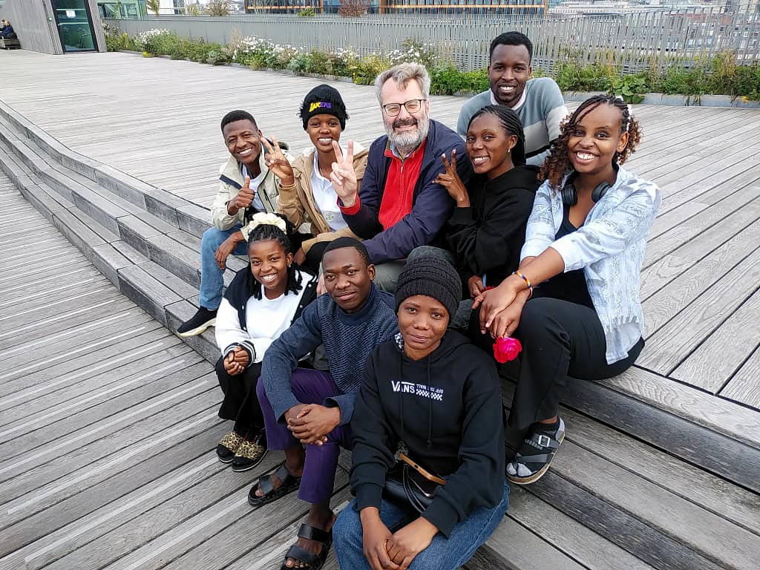

## **Evening: Departure and Journey Home**

In the evening we got ready for the trip back to Tanzania. Our Belgian coordinators helped us to travel by train from Pieter Blugel Hostel to Brussels Airport.

A good-bye was an emotional moment but we were quite proud and very thankful to have been the representatives of Mwenge Catholic University (MWECAU) and Tanzania in this international program.

## **Reflection**

The last day was a mix of emotions and inspiration. The visit to the Cathedral of St. Michael and St. Gudula was a great reminder of the power of history, faith, and unity. The farewell reflection helped us recognize the importance of cultural diversity and that we could apply what we had learned in our own societies.

With the end of NIP program, not only did we take home from Belgium the new knowledge but also the lifelong friendships and the unforgettable experiences. We went back to Tanzania with a more assertive global citizenship that was ready to take part in the positive change through education, collaboration and cultural understanding.

# **Final Conclusion and Overall Reflection**

The North Intensive Program (NIP) in Brussels, Belgium, from 11th to 19th October 2025 was a memorable and a turning point in one's life experience. While the nine days were passing, we had a chance to uncover European history, culture, democracy, social work, sustainability, and art in different ways and at the same time have nice intercultural exchanges with Belgian students and professors.

The program provided us with the chance to see the important historical and educational sites like the House of European History, Royal Museum of Fine Arts, Molenbeek, BIGH Urban Farm, Belgian Federal Parliament, Hogeschool Brussels, and the AfricaMuseum in

Tervuren. Every single visit presented different taught us about the interaction between history, governance, environment and culture to the development of societies.

We were taught about how the European Union was created, the essentiality of freedom, unity, and democracy, as well as how Belgium takes the multilingual and multicultural identity issue into consideration. Through social and academic interactions, we realized the significance of communication, cooperation, and mutual respect among people with different backgrounds.

The program did not only expose us to these global challenges like climate change, migration, and urbanization but also the innovations, education, and social responsibility ways to tackle such issues. Institutions like BIGH Farm and HANGAR Art Center were among those that surely brought the message home that creativity and sustainability could indeed be the keys to modern problems.

Besides, the program was a cultural one that helped us to be aware of the importance of heritage preservation, both in Brussels and in Tanzania. Visiting the Grand Place, Cathedral of St. Michael and St. Gudula, and other monuments made it clear to us that the future cannot be guided unless the past gets protected. The Africa Day visit to Tervuren’s AfricaMuseum made us adopt a prideful, honest, and growth-oriented perspective towards Africa’s history.

On a personal level, this exchange has been a great boost to our confidence, teamwork, and communication skills. It was the opportunity to not only make friends with Belgian students that would last a lifetime but also to impart our Tanzanian culture with pride. We were also taught the value of critical thinking, cultural tolerance, and global citizenship.

## **To sum up,**

The NIP program was simply not an academic experience but also a journey of personal growth. It opened our eyes to the idea that knowledge is a product of exposure, conversation, and working together.

We're inspired as Tanzanian students to return and put into practice everything we've learned by enforcing positive changes in sustainability, social inclusion, and education in our neighborhoods.

Mwenge Catholic University (MWECAU), Erasmus University College Brussels, and all the professors and mentors, particularly Prof. Stefan Moens, to whom we are most thankful, are the ones who made this program outstanding and influential.

The knowledge we acquired in Brussels will have a lasting influence on our beliefs and our active participation in the creation of a better, more interconnected, and peaceful world.